**Agenda**

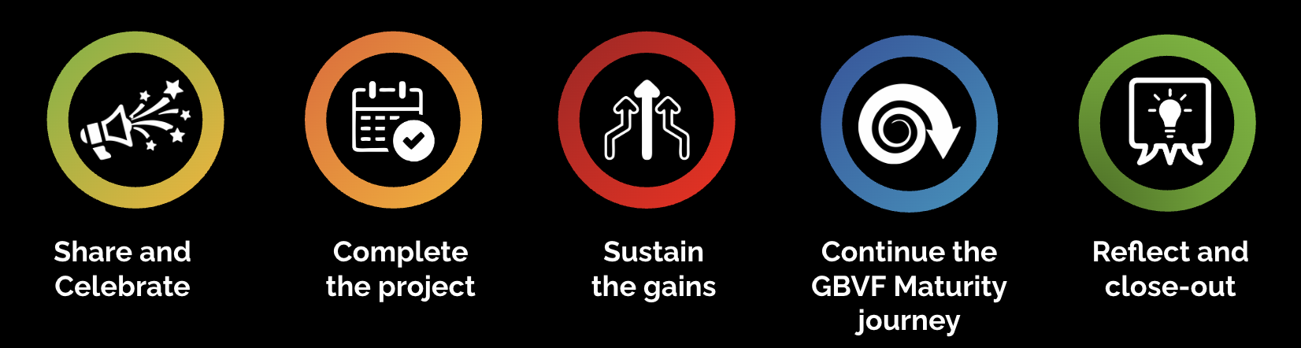

| **Timing** | **Workshop elements** |
| --- | --- |
| 60 min | Share and celebrate |
| 30-40 min | Complete the project (only if outstanding activities) |
| 20 min | Comfort break |
| 40 min | Sustain the gains |
| 30 min | Continue the GBVF Maturity journey |
| 30 min | Reflect and close-out |

| Timing is a guideline only. This **facilitation guide** is only a summary of the steps. Completing the online guides on the World of Impact platform is critical to fully understanding each section's why, how, and tips. |
| --- |

| **Share and celebrate (60 min)** |
| --- |
| **1. Opening** to set the tone that today celebrates success and learning.   * **Welcome** team members, mentors, and other leaders to the Workshop and share the objectives and agenda.   **Check-in** – Use a positive and inspiring check-in question. For example, share one thing that surprised you about yourself in the past 30 days – a small discovery, a moment you savoured, etc.  **2. Listen** – Ask stakeholders in the room (from outside the team) to take notes during the show & tell:   * Questions to ask afterwards * Team practices to try in other parts of the organisation * Suggestions for the team   **3. Show & Tell** – In the midst of all the creative work the team has done to present their experience, make sure the team touches on the following:   * The 30-Day goal * Progress towards the goal * Other achievements the team is proud of * Problems encountered and how these were handled * Innovations the team tried – and what they learned from these * Personal shifts and transformations – how team members were affected by the experience   **4. Reflections and & Comments**   * Invite others in the room (leaders and possibly members of other 30-Day teams) to comment on what they heard: what surprised them? What inspired them? Where do they see the possibility of replicating some of what they heard? What questions do they have * Offer your reflections on the experience supporting the team. Make these reflections about the team and not about yourself. |
| **Complete the project (30-40 min)** |
| * **Set the Stage:** Applaud the team’s incredibly hard work over the past 30 days. And despite that, *“the team is eager to complete a few more tasks that will enable them to declare complete victory as they cross the finish line.”* * Invite the team to **present the “Final Sprint” Plan** they developed in preparation for the Landing Workshop * **Invite the Mentor and Leaders to comment** on the plan: * *“Does this seem reasonable?”* * *“Are you OK with extending the team mandate by another x days?”* * *“Can you commit to the support they are requesting to complete their final sprint?”* |
| **Sustain the gains (40 min)** |
| 1. **Set the Stage:** *“The team has done some thinking on what it will take to ensure that the gains they made in the last 30 days can be sustained and even amplified. They will present action recommendations to leaders. It may not be possible to make decisions on these here and now, but we’d love to hear initial perspectives on these from the leaders in the room.”*      1. **Present Recommendations.** Invite the team to present the Sustainability Action Recommendations they developed in preparation for the Landing Workshop. 2. **Solicit Feedback from the Leaders.** For each recommendation:  * *“What are your initial thoughts on this?”* * *“Is there consensus or decision that that organisation can commit to this?”*   + “If yes, who will be responsible for ensuring it happens?”   + *“If this requires more deliberation by leaders, when will you be able to get back to the team with a decision? And who will own this decision?”* |
| **Continue the GBVF Maturity journey (30 min)** |
| * **Set the Context:**  *“The team will share their thoughts on where to go from here, in terms of additional 30-Day Challenges that will move us forward on our GBVF maturity journey.”* * **Proposed Road Map Ahead.** Invite the team to present their thoughts on what to focus on next. * Follow-on 30-Day Challenge? * New focus area for 30-Day Challenge? * Multiple 30-Day Challenges as once? * **Leadership Decisions:**  Invite leaders to have a conversation about the options proposed by the team. If a decision is made to proceed with one or more options, facilitate a conversation to decide on (a) a mentor for each 30-Day Challenge and (b) the timing to get this underway. Leaders can also decide on team members for each 30-Day Challenge if there is time and energy. |
| **Reflect and close-out (30 min)** |
| * **Gratitude.** Thank the leaders for their engagement and for “agreeing to be on the spot.” * **Assessment of the 30-Day experience.** Use the mentimeter you created before the workshop to get feedback from participants on their experience of the 30-Day challenge.   Questions to include :   * + - Rate your perceptions of the extent to which the three hallmark behaviours emerged in the past 30 days? You can use a scale from 1-5, with 1- Not changed and 5 being dramatically more     - More intense collaboration?     - Faster innovation?     - More disciplined implementation?     - *“To what extent would you recommend this experience to colleagues and peers invited to participate in a 100-Day Challenge on GBVF?”*        * + This is the Net Promoter Score (a method of using a single survey question to gauge satisfaction with a product or experience). Vote from 1 to 10, with 1 standing for: *“Are you kidding me? I’ll tell them to run to the hills…”* And 10 is *“I would recommend it wholeheartedly and with zero reservations”.*     - Write a short note to future 30-Day Challenge team members with advice to them. * **Workshop feedback** (5 min): Ask the team to complete the short workshop feedback survey to help improve your facilitation. * **Appreciations.** Ask team members to reflect (individually and silently) on specific things that others did during the 30 days that were over and above the call of duty and that they particularly appreciated. Find a creative way to have them share this. See below for some ideas on how to do this.   **Photo** - Take a group photo and photos of the flip charts in case these get lost. |