**Agenda**

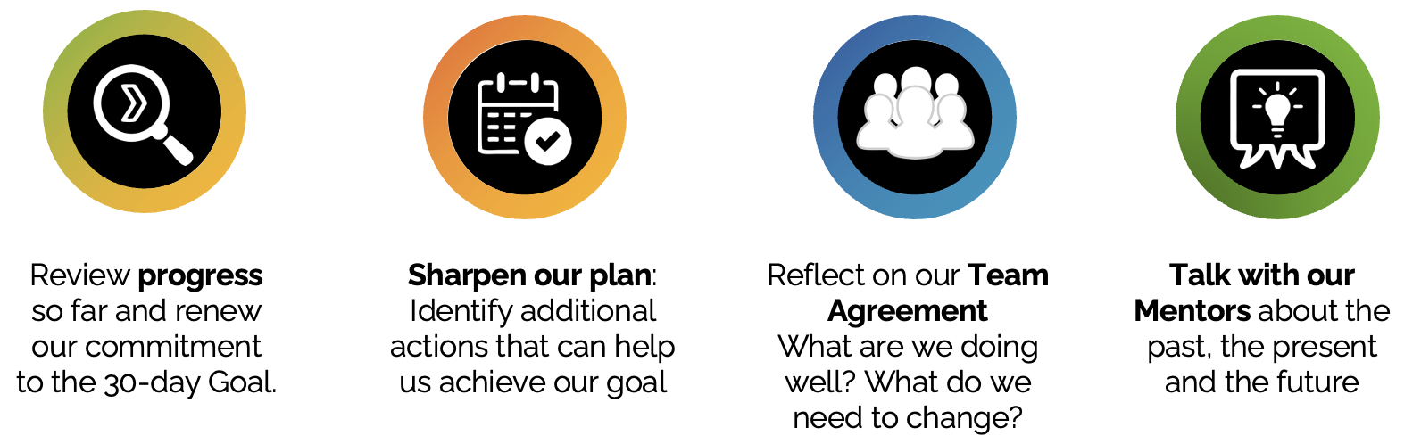

| **Timing** | **Workshop elements** |
| --- | --- |
| 60 min | Renew commitment to our goal |
| 60 min | Sharpen our plan |
| 20 min | Comfort break |
| 30 min | Reflect on our team agreement |
| 60 min | Talking to leaders and close-out |

| Timing is a guideline only. This **facilitation guide** is only a summary of the steps. Completing the online guides on the World of Impact platform is critical to fully understanding each section's why, how, and tips. |
| --- |

| **Renew commitment to our goal (60 min)** |
| --- |
| **1. Welcome and warm up -** Welcome everyone back and share the objectives and agenda of the workshop. For the warm-up exercise, use the 1-2-4 All exercise (See video below), to discuss the following questions:   * What was a pleasant surprise about working on this team? * What was a not-so-positive experience working with this team? * What made you a little uncomfortable   **2. Progress -** To get into a positive spirit, ask each team member to share 2-3 things the team did that helped make progress towards the goal. These could be post-it notes or just sharing.  **3. Confidence vote:**   * Ask each team member to do a **vote of confidence on the goal** (It is best to ask them to pick a number and reveal this at once on post-its or use a Mentimeter survey)   + 1 = “no way in hell, no chance to reach our goal”   + 5 = "100% sure we will achieve this.” * **Discuss differences**: Use the votes to ask probing questions and facilitate a conversation among team members:   + What makes you feel so confident?   + Why are you so pessimistic?   + What would it take to push your confidence up by 1 or 2 points?   + What will need to happen in the next two weeks to move your vote above 4? (Have someone capture these ideas on the flip chart. They will come in handy to strengthen the plan.)   **4. Changes to the goal -** Depending on the votes and the discussion, ask whether we can proceed with the goal, whether we should nudge it up ”to keep things exciting and challenging," or whether we need to shift it down. Then, let the team know that we will revisit these ideas when we sharpen our work plan. |
| **Sharpen the plan (60 min)** |
| **1. Difficulties -** Ask each team member to consider one issue related to the project that they are having difficulties with and would like help and advice on. These issues may have come up in the previous session.  **2. Advice -** Use **TROIKA Consulting** (see the video below) to solicit fast and fresh advice from each other on these issues. If the team is only 4 people, three people can participate and one can give the instructions and keep time.  **3. Adjust the plan -** Ask the team to adjust the work plans based on the advice they received. And also, ask them to consider the question: "What else can we do to increase the odds of success? What new ideas can we pursue?" (outside the current plan). Make sure to remind the team to go review the ideas that emerged in the previous session and to turn these into concrete actions that can be added to the work plan.  **4. Review the emerging work plan** and make sure timing is aligned across work streams. Once that is completed...   * Ask the team to vote on their goal achievement confidence again. * Ask them to decide on specific requests for support they may have of the mentor(s) |
| **Reflect on our team agreement (30 min)** |
| **1. Living into our agreement?**  Load the team agreement on a Mentimeter or hand out a copy of the agreement to each team member. Ask the team to vote on a scale from 1-7 on “how well we are living into each element of the agreement.” Use 1 for "not at all", and 7 for "we are completely living into this".  **2**. **Zero in on 2-3 elements of the agreement that got a low score** (relative to others). Ask team members to consider the question: "What things can we do in the next two weeks to score better on this?" If there are many ideas, ask team members to vote on the three with the highest impact. You can also do this in real-time in centimetres. If there is implementation involved, ask volunteers to own the top voted ideas.  **3**. Ask everyone to think about **recommendations to adjust and strengthen** the agreement. Go around and solicit recommendations. Do thumbs-up majority voting (if need be) to decide whether to adopt or reject each recommended adjustment/addition. After you adjusted the agreement on paper or the flip chart, ask everyone to **sign** it. |
| **Talk to leaders and close-out (60 min)** |
| **1. Asks from Mentors**: Ask the team to prepare bullet points on specific support from the Mentor that the team will need in the next two weeks.  **2. Sustainability:** Ask the team to imagine that on day 30, they have been wildly successful in achieving their goal, but that in the next Organisational GBVF Health Check, the results returned to where they were before the 30 days. Brainstorm, using post-it notes, why performance dropped, group similar post-its into "sustainability risk" buckets, and name each.  **3. Actions against risks:** Ask for volunteers to focus on each sustainability risk bucket. Send them into breakout groups to discuss and come back with actionable steps or actionable recommendations for the Mentor, as these relate to two questions:   * What can the team or others do in the next weeks to minimise this risk? * What changes need to be implemented to avoid this sustainability failure: policy changes? Process changes? Role changes? Etc.   **4.** Debrief and prepare a **short presentation to the Mentor and leaders**, including the support needed and ideas from the "sharpening the plan" discussion. This can be done in the form of:   * Looking back: Share the revised goal and highlights from the revised plan. * Looking at the present: Thank the leaders and Mentor for the support they provided so far, and ask for support the team needs now. * Looking forward: Share recommendations on risk mitigation and changes related to sustaining the gains.   **5. Close-out:**   * **Workshop feedback:** Ask the team to complete the short workshop feedback survey to help you keep improving. * **Appreciations:** Introduce the activity by emphasizing the importance of appreciating each other in this work. On the online guides there are a fun example of how to express appreciations. “Paper Plate Awards” * **Closing comments –** go around the room and ask each team member to respond to a question with one word. Questions you could use: "Share one word that best describes how you feel about your experience so far" OR "how you feel about the next two weeks?" Ask the Mentor or leaders to give the last final word. * **Photo** - Take a group photo and photos of the flip charts in case these get lost. |